* **Installing LAMP Server in Ubuntu !8.04**

Step1:- Install apache using Ubuntu’s package manager **apt** with command below to allow HTTP and HTTPS traffic for the server

**apt install apache2 –y && ufw allow in "Apache Full"**

If you see the default Apache Homepage in browser by typing [**http://your_server_ip**](http://your_server_ip)**.**

You will see the default Home page of Apache2 Ubuntu which looks like this.

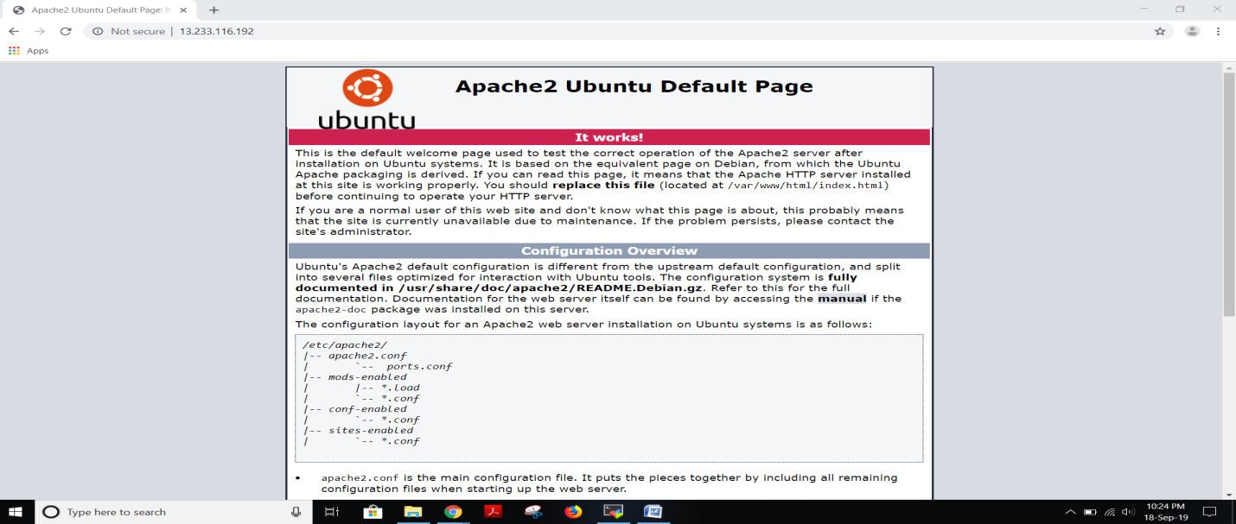

Step2:- Install mysql with command below command and also perform secure installation to remove some dangerous defaults and which will block unnecessary access to database.

**apt install mysql-server –y && mysql_secure_installation**

While running above command it will ask to enable VALIDATE_PASSWORD_PLUGIN and then provide password for database which we will use to access the database.

Step3:- Install PHP and PHP MyAdmin with the below command

**apt install php 7.2 php libapache2-mod-php php-mysql && apt install phpmyadmin**

The above command will open a dialog box where we need to select the apache and then it will ask us to provide the password for PHP MyAdmin.

Go to html root directory i.e:- **/var/www/html** and create html file named **info.php.** After this we can see the phpinfo page in browser by typing [**http://13.233.116.192/info.php**](http://13.233.116.192/info.php)**,** which looks like this.

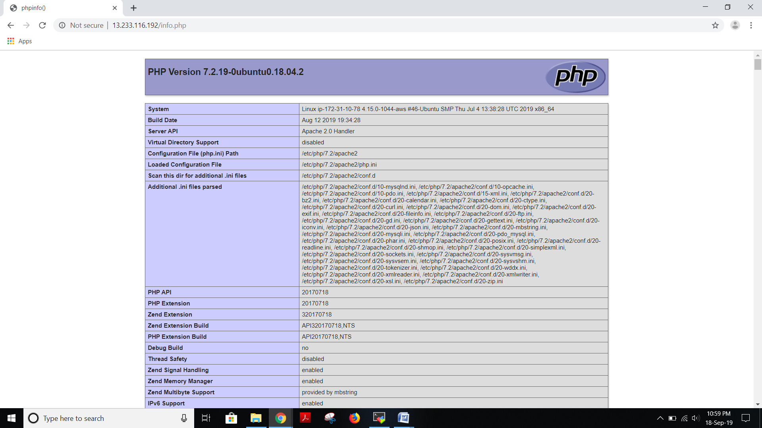

After creation of phpfile in HTML root directory, the you need to modify the Apache web server file then it looks for PHP files over other files. It opens directory configuration file and place phpfile at the beginning.

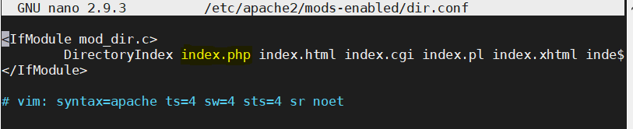

Step4:- Go to browser and type [**http://13.233.116.192/phpmyadmin/**](http://13.233.116.192/phpmyadmin/) **,** and then it opens a phpmyadmin homepage.

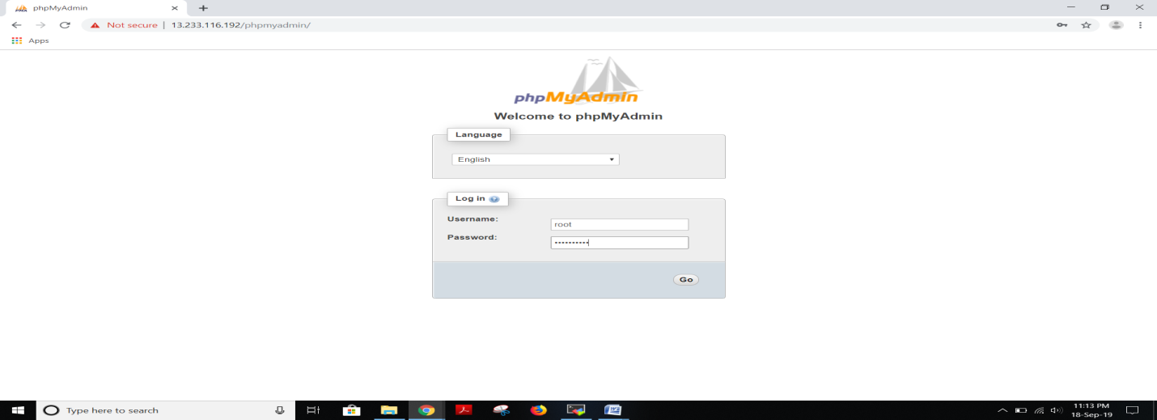

Step5:- Enter username and password to log into the phpmyadmin database. Here we will see the database homepage.

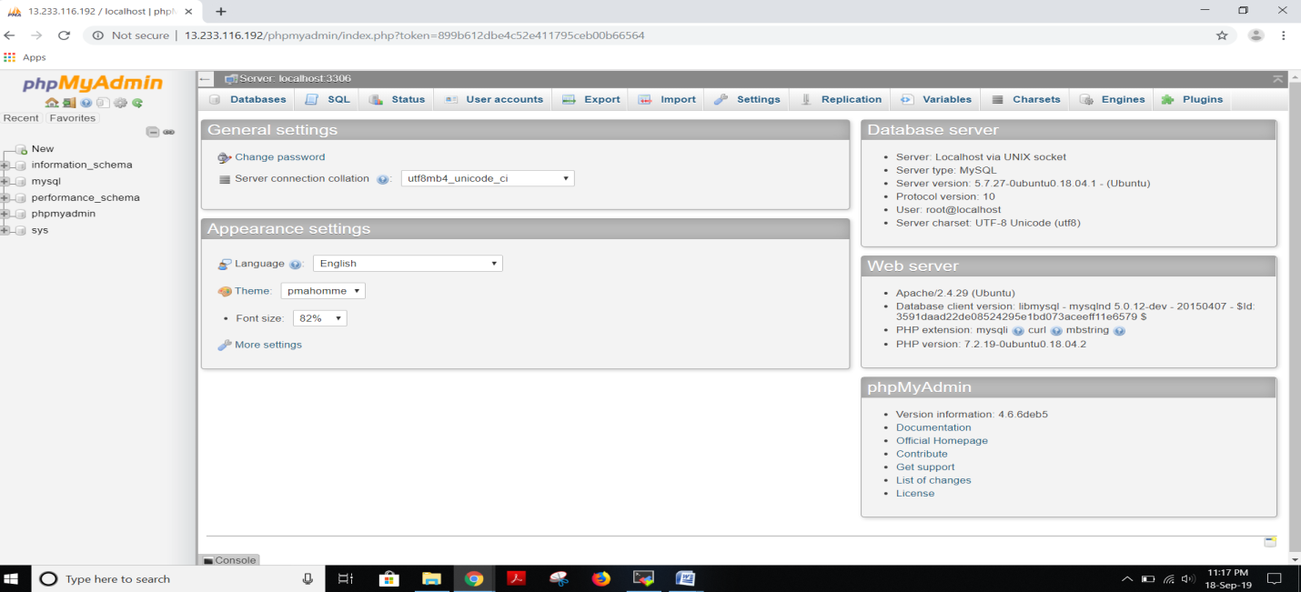

The LAMP installation in Ubuntu 18.04 has successfully installed.